Information for SAEOPA Southern African Essential Oil Producers Association 2022-2023

HS Code 33019090 for essential oils under Chapter 33
3301
Essential oils (terpeneless or not), including concretes and absolutes; resinoids; extracted oleoresins; concentrates of essential oils in fats, in fixed oils, in waxes or the like, obtained by enfleurage or maceration; terpenic by-products of the deterpenation of essential oils; aqueous distillates and aqueous solutions of essential oils

US Hs Code - 3301 : Essential oils; resinoids; extracted oleoresins; concentrates of essential oils, etc
330111 | Oils of bergamot, whether or not terpeneless, incl. concretes and absolutes
330112 | Oils of sweet and bitter orange, whether or not terpeneless, incl. concretes and absolutes (excl. orange-flower oil)
330113 | Oils of lemon, whether or not terpeneless, incl. concretes and absolutes
330114 | Oils of lime, whether or not terpeneless, incl. concretes and absolutes
330119 | Essential oils of citrus fruit, whether or not terpeneless, incl. concretes and absolutes (excl. those of bergamot, sweet and bitter orange, lemon and lime)
330121 | Oils of geranium, whether or not terpeneless, incl. concretes and absolutes
330122 | Oils of jasmin, whether or not terpeneless, incl. concretes and absolutes
330123 | Oils of lavender or of lavandin, whether or not terpeneless, incl. concretes and absolutes
330124 | Oils of peppermint "Mentha piperita", whether or not terpeneless, incl. concretes and absolutes
330125 | Oils of mints, whether or not terpeneless, incl. concretes and absolutes (excl. those of peppermint "Mentha piperita")
330126 | Oils of vetiver, whether or not terpeneless, incl. concretes and absolutes
330129 | Essential oils, whether or not terpeneless, incl. concretes and absolutes (excl. those of citrus fruit, geramium, jasmine, lavender, lavandine, mint and vetiver)
330130 | Resinoids
330190 | Extracted oleoresins; concentrates of essential oils in fats, fixed oils, waxes and the like, obtained by enfleurage or maceration; terpenic by-products of the deterpenation of essential oils; aromatic aqueous distillates and aqueous solutions of essential oils

Country specific extensions:
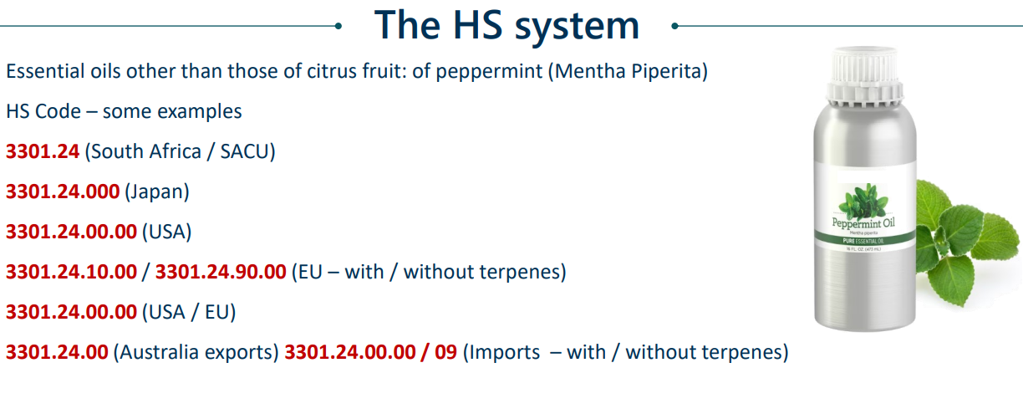
Fast facts essential oils
- France is a major importer of oils that fall within the HS code “not elsewhere specified”, in particular higher-value oils used in cosmetics.
- In 2017, France accounted for 23% of the total European imports in volume and for 32% of the imports in value. The French market is particularly appealing for specialty oils used in the cosmetics sector and acts as a hub for the industry across Europe.
- Vegetable seed oils 15159020 used for neem, cotton seed, and water melon seed oil as carrier oils
- Marula and Baobab Oil Export Data may be under HS Code 33012990 as export data and product (s) under 33012990 code is collected from Indian customs, ports, and other reliable authorities in India.
- Marula oil from France to Turkey HS Code used: 151590600000

SUMMARY of South African produced oils: It depends on the buyer and supplier which code is preferred.
Geranium oil | 330121/9
Classic oils: Lavender | 330123 /33012979
Lemon grass | 33012942 /33011990
Rosemary | 3301990
Citrus | 330111/3/4/5
Eucalyptus | 33012924
Buchu | 33012941 /33019090
Tea tree | 33011990
Cape chamomile | 33019090
Helichrysum | 33019090
Vetiver | 330126
Lippia javanica | 33019090
Baobab, Marula | 33012990 some use 15159020 /1515905900
Kalahari Melon | 33012990 some use 15159020 /1515905900

